AI Camera 2.0 Basic Projects

Lesson 2: Pose-Imitating Robot
Ages: 12 and up
Duration: 45 minutes

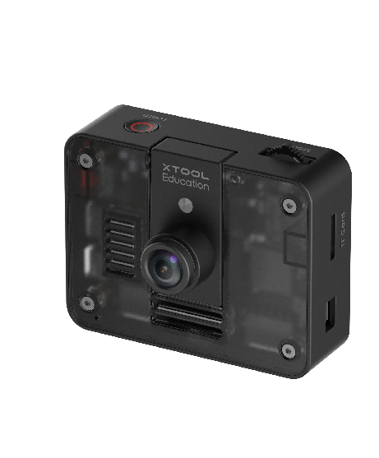

Objectives:
By the end of class, students will be able to:
- Understand the basic concepts of computer vision and pose recognition
- Master fundamental methods of coordinate mapping
- Learn to control servo motors and program robots

Overview
In this course, students will explore an advanced artificial intelligence technology — human pose detection. We will give robots “smart eyes” so they can capture and imitate human movements in real time. Students will first observe how their own body movements are broken down into a series of digital coordinates through an AI camera. Next, they will build a “smart bridge” by writing code that maps the Y-coordinate values of their left and right hands, captured by the AI camera, to the rotation angles of servo motors on the mBot2 robot.

Pre-lesson Checklist
For the teacher:
- Computer with mBlock installed and tested;
- Adequate number of mBot2 robots (fully charged);
- AI Cameras compatible with mBot2;
- CyberPi and connection cables;
For the students:
- Computer with mBlock installed and ready;
- mBot2 robot and AI camera set per group;
- CyberPi and connection cable;
- Workspace cleared for testing and experimentation;
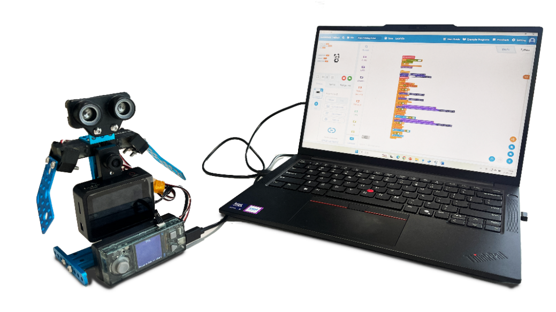

Agenda (45minutes)
Duration | Content
5 minutes | Section 1 - Introduction  - Demonstrate how the programmed mBot2 can imitate the motion of moving your hand up and down;  - Prompt interaction: “How is the mBot2 able to imitate my movement?”
10 minutes | Section 2 - Explore  - Understand the screen coordinate system and the principle of key point tracking;  - Learn how servo motors work and master basic control methods;
15 minutes | - Section 3 - Create and practice  - Set up the programming environment and obtain key point pose coordinates;  - Program a mapping bridge to achieve imitation control;
10 minutes | Section 4 - Presentation  - Invite 2-3 groups of students to demonstrate their creative ideas and insights;  - Compare and talk about the differences among their works;
5 minutes | Section 5 - Evaluate  - Review the problems they met and how they solved;  - Try replacing keypoints to design new creative examples;

Activities

Section 1 - Introduction
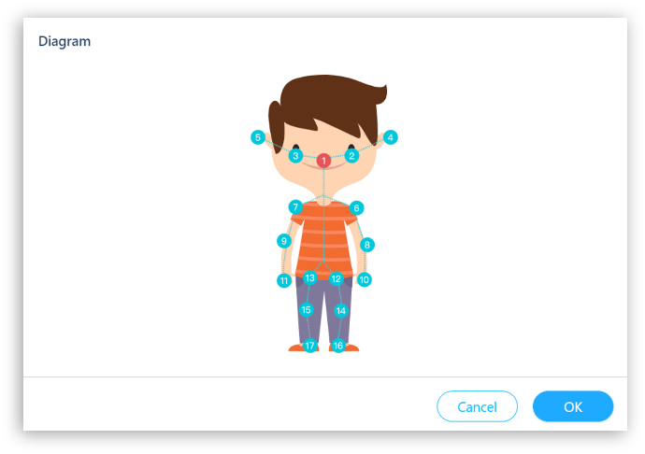
In today’s lesson, we will explore how artificial intelligence and robots work together. Using an AI camera, you will capture your own body movements and learn how computer vision recognizes human actions. You will experience the entire process—from detecting key points in a pose to controlling a machine—and discover how to turn the motion of your hands into signals that steer servo motors. By the end, you’ll use your own movements to control an mBot2 robot in real time!

Section 2 - Explore
In this section, students will observe how the AI camera turns body movements into digital coordinates and learns the principles behind pose recognition. Students also explore how servo motors work and learn to control them accurately. Finally, students will build a “smart bridge” that converts key point coordinates into servo motor angles.
Step 1: Explore your body’s digital coordinates. Run the pose recognition program and raise your right hand. Watch the key points appear live on the screen. Slowly move your hand and observe how the X and Y values change. You’ll learn how the AI camera turns real movement into digital signals.
Step 2: Learn to control the servo motor. Get a close-up look at how a servo motor is built and how it works. Test its range of motion from 0° to 180° and see how it responds. Then complete a basic task: write a program to rotate the servo motor to specific angles.
Step 3: Build a smart mapping bridge. Learn how to translate screen coordinates (0–480) into servo angles (0–180). Adjust settings until the mBot2’s movement matches your own smoothly and naturally.

Section 3 – Create and practice
In this section, students will transition from theory to practice. Working in small groups, they will build a movable robot and program it to imitate human movements.
Task 1: Set up the programming environment and obtain key point coordinates
Step 1: Enable pose recognition. Add the [AI Camera 2.0]and [Expansion Board] extensions in mBlock. Write an initialization program so that when CyberPi starts, it automatically activates the pose recognition function and turns on the AI Camera’s pose recognition mode. | 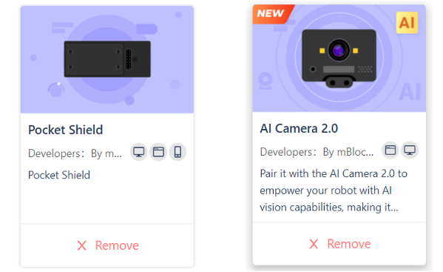
Step 2: Capture hand coordinates. Write a program that allows the AI Camera to detect the Y-coordinates of both hands. Run the program and wave your hands in front of the camera. Use the “Left Wrist Y-coordinate” and “Right Wrist Y-coordinate” code blocks to display the coordinates in real time on the CyberPi screen. | 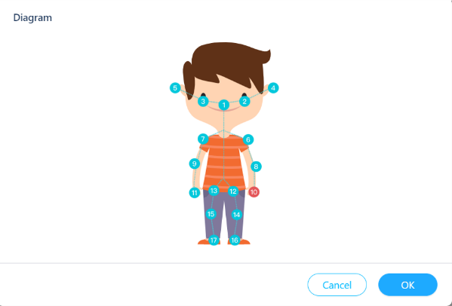

Task 2: Convert Hand Y-Coordinates into Servo Rotation Angles
Step 3: Create motion mapping. Using either a mapping tool or a mathematical formula, convert the left wrist’s Y-coordinate value into a target rotation angle for the servo motor. Use a loop to continuously send the converted angle values to control the servo’s movement.  Step 4: Test and calibrate. Wave your hand and observe how the robot responds. Continuously adjust the mapping parameters until the robot’s imitation motion becomes smooth and synchronized with your movement. | 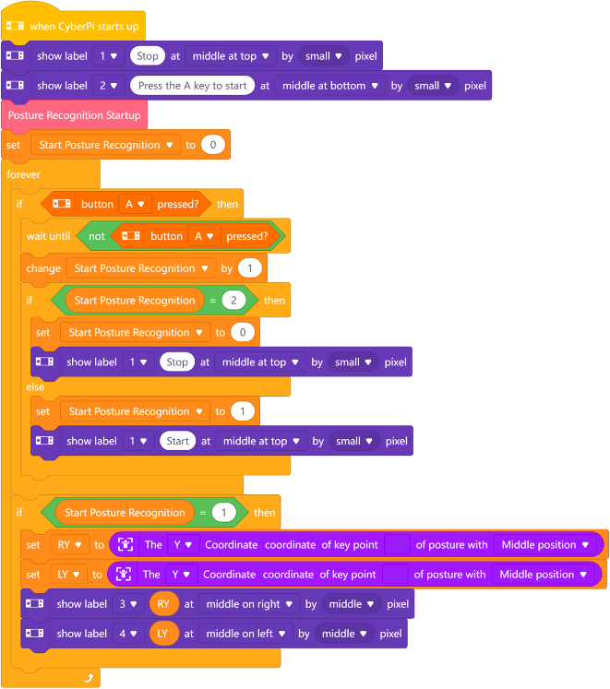

Section 4 - Presentation
In this session, students will show and compare their projects. During your demonstration, please have the students explain: What detecting key points did you design for controlling a machine, and why did you choose this design approach? What challenges did you encounter during the process?
After 2-3 groups have presented, the teacher will guide a whole-class discussion. Please observe carefully: What are the similarities and differences in their solutions? What is the smartest part of their designs? Secondly, what ideas would you borrow from other groups’ designs?

Section 5 - Evaluate
Now let's review some key points in this lesson.
- What was the biggest challenge you faced in today's project? How did you and your team work together to solve it?
- Besides controlling a car, where else do you think pose recognition technology could be used to help people or make life more fun?

